1. **Creating and Renaming Files/Directories**Screenshot:  
   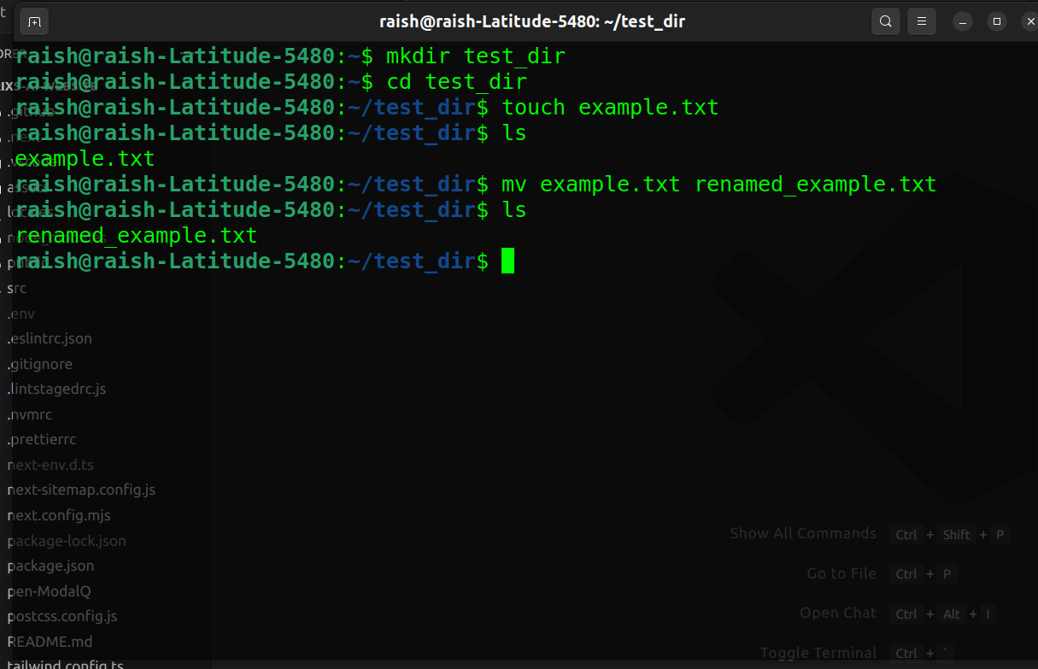

Explanation:

mkdir creates a new directory.  
cd changes the working directory.  
touch creates an empty file.  
mv renames or moves files.  
  
  
  
  
  
  
  
  
  
  
  
  
**2. Viewing File Contents**

Screenshot: 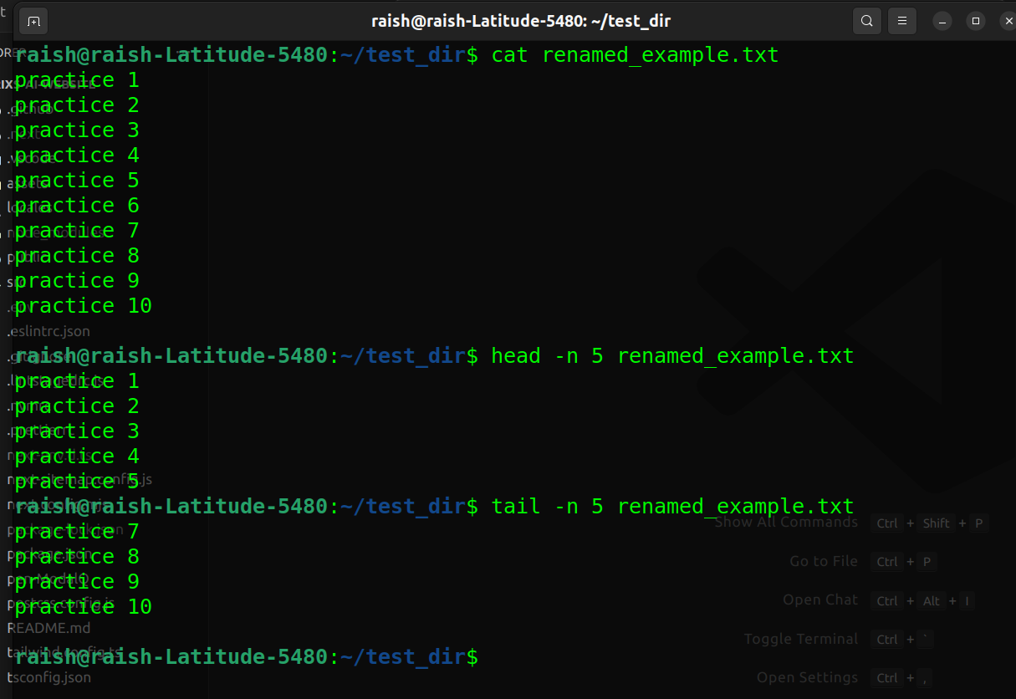

Explanation:

cat displays the entire content.

head -n 5 shows the first 5 lines.

tail -n 5 shows the last 5 lines.

**3. Searching for Patterns** Screenshot:

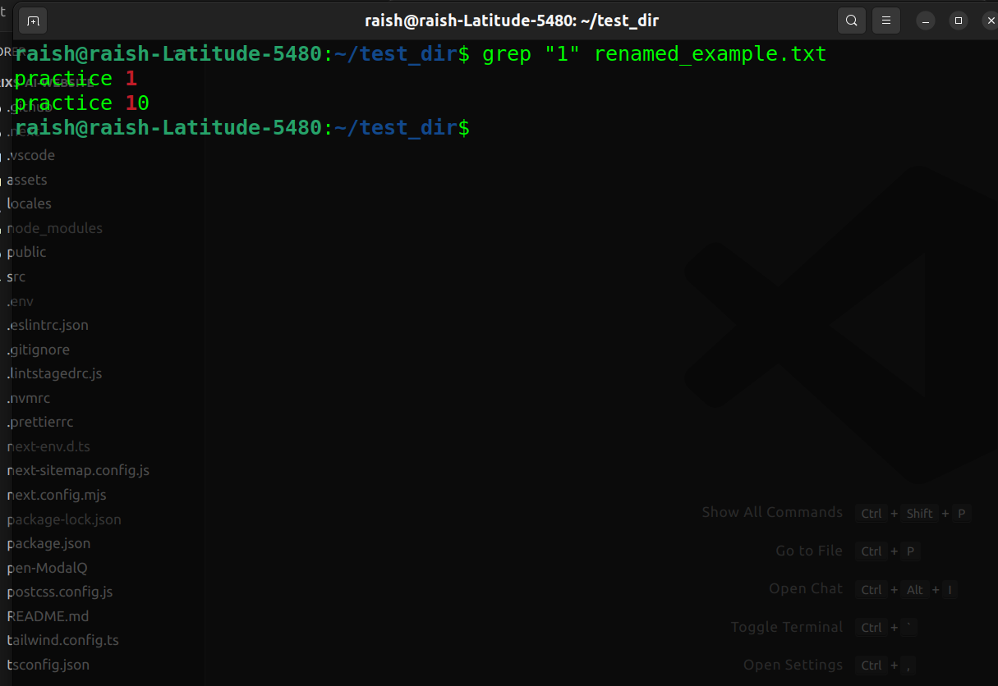

Explanation:

grep searches for the keyword "1" in renamed_required.txt and prints matching lines.

**4. Zipping and Unzipping**Screenshot:

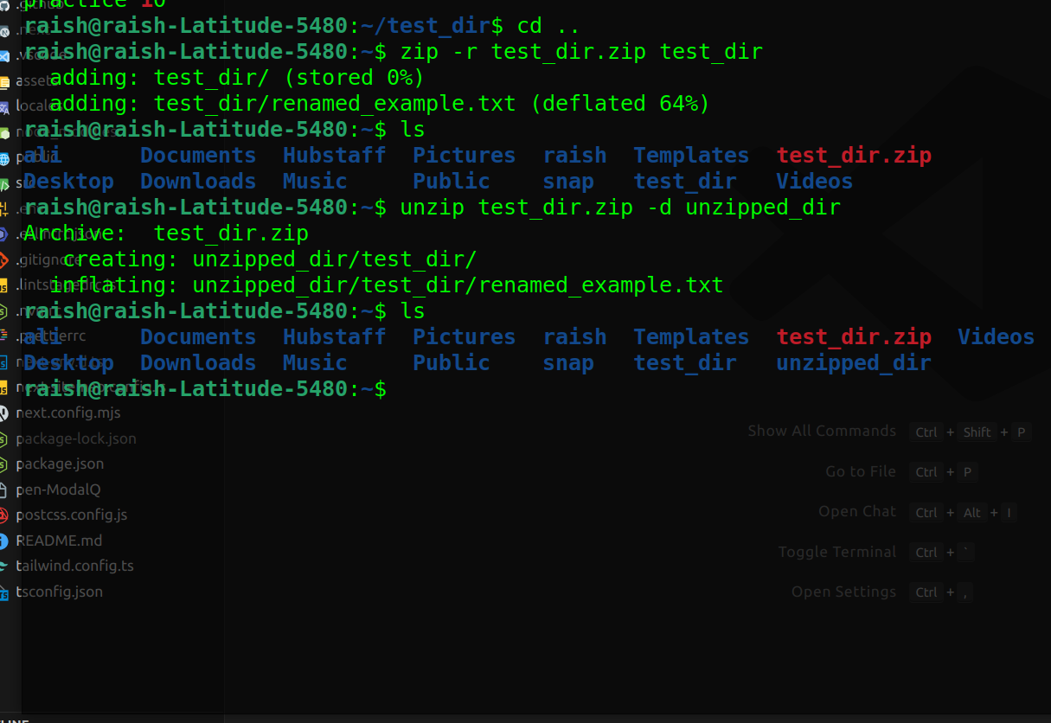

Explanation:

zip -r compresses a directory recursively.

unzip -d extracts to a specific directory.

**5. Downloading Files**

Screenshot:

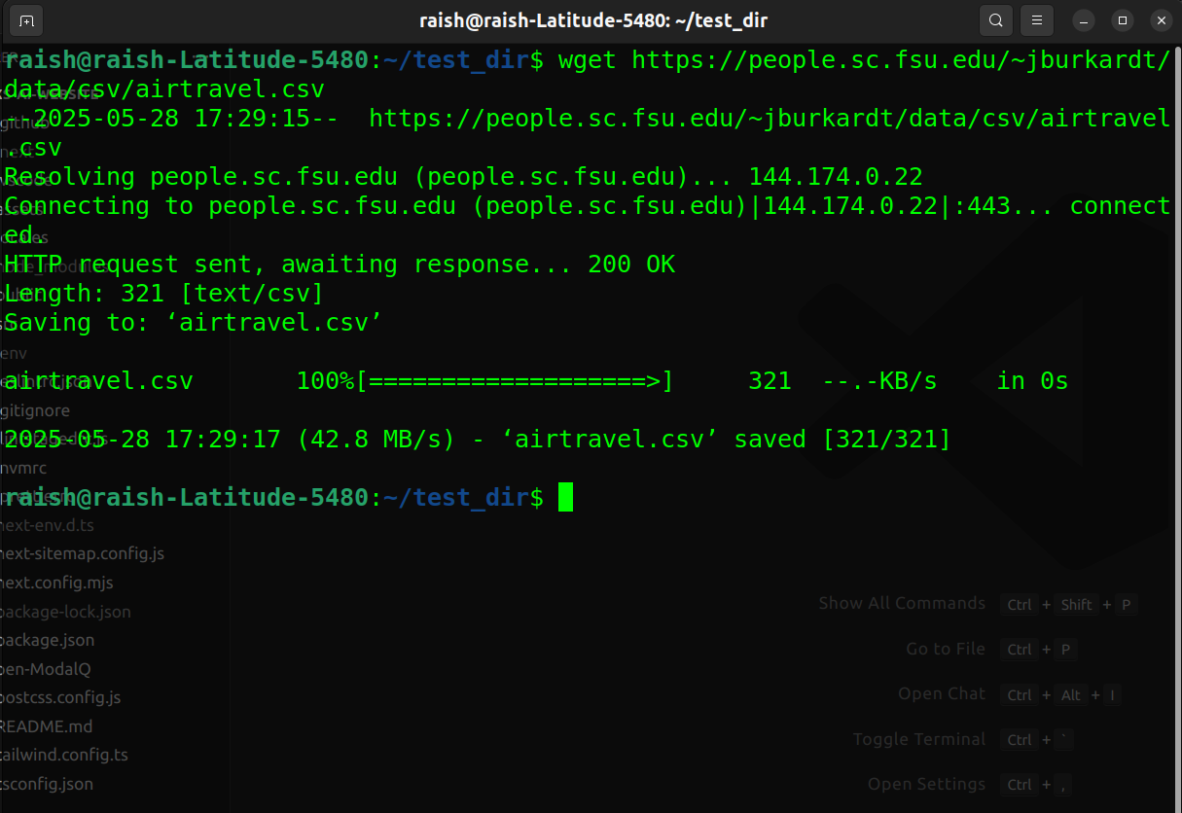

Explanation:  
used this <https://example.com/sample.txt> url but getting 404 error so i preferred this url <https://people.sc.fsu.edu/~jburkardt/data/csv/airtravel.csv>  
  
wget downloads files from the web using HTTP/HTTPS.

**6. Changing Permissions**

Screenshot:

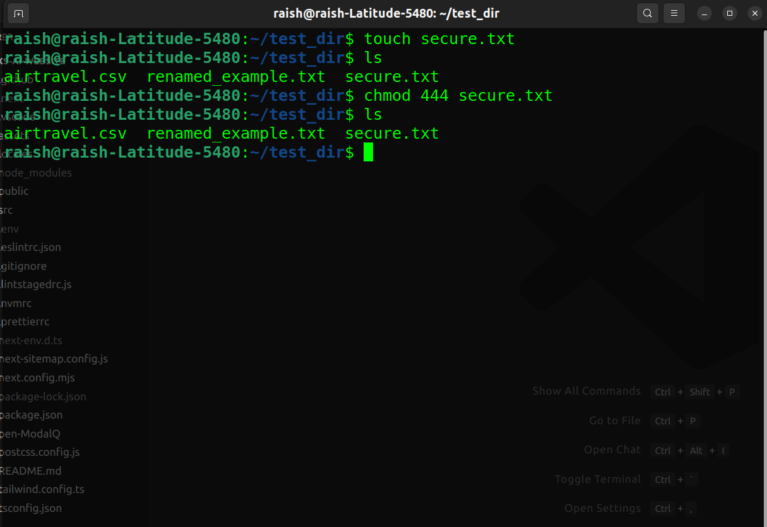

Explanation:

chmod 444 sets the file to read-only for user, group, and others.

**7. Working with Environment Variables**

Screenshot:

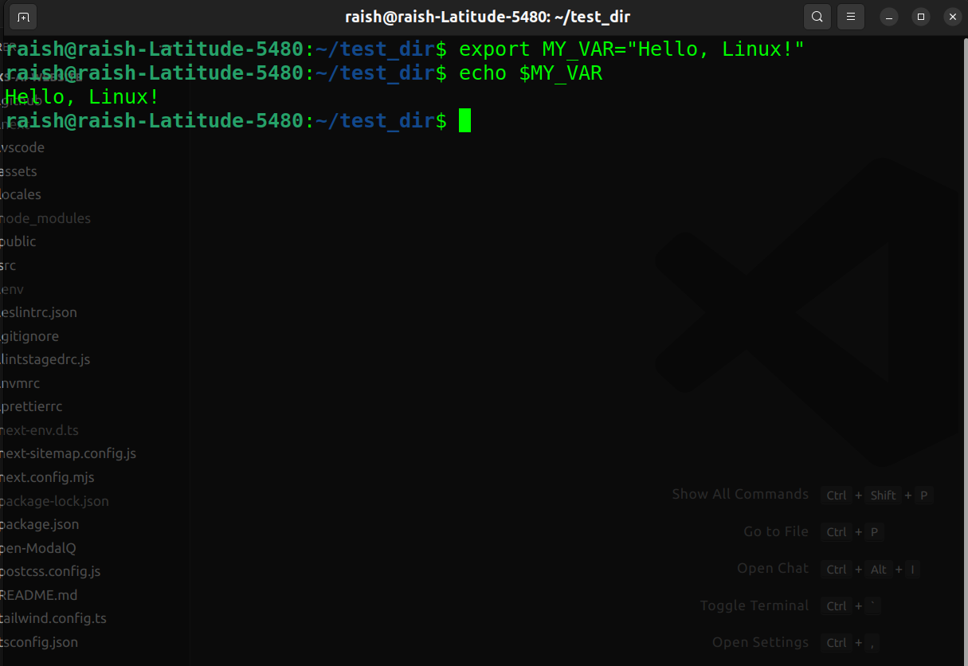

Explanation:

export creates a new environment variable.

echo prints the value of the variable.